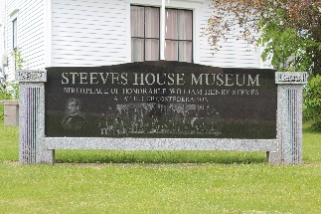
VOLUNTEER APPLICATION FORM

Submit your completed form in person during the summer season, by appointment in the off season, by mail to 40 Mill Street, Hillsborough, NB E4H 2Z8, or by email to steevesmuseum@nb.aibn.com. Repeat volunteers can receive resume references upon request. For questions email us or call 506-734-3102. Note: calling is only reliable during the summer season, but email works year-round.
CONTACT INFORMATION
Name________________________________________________________________________________
Address______________________________________________________________________________
City_____________________________ Province___________________ Postal Code _______________
Home Phone_________________________________ Cell Phone _______________________________
Email________________________________________________________________________________
SKILLS & EXPERIENCES
If you have any skills or experiences that may benefit the museum in any way let us know! Do you have computer or artistic skills? Are you a genealogy nut? Do you have food service experience? Are you a gardener? Do you have any construction or technical skills?
_____________________________________________________________________________________
_____________________________________________________________________________________
_____________________________________________________________________________________
VOLUNTEER OPERTUNITIES
What type of volunteer opportunities are you interested in or able to participate in?
All the Below
Community Events
Meal Serving Events
Museum Tours
Genealogy
Social Media Story Writing
Gardening
Lawn Mowing
Cleaning
Maintenance/Repairs
Are there specific events, like the Garden Party, or other activities you would like to help with?
_____________________________________________________________________________________

Thank you for your support!
Steeves House Museum / Heritage Hillsborough Inc.
steevesmusuem@nb.aibn.com www.steeveshousemuseum.ca

